Tower Defence Game

Temp Title - Proctle (Procedural Projectile)

Roles -

Connor Leonie (Everything for now)

Possibly a musician (Patrick maybe?)

Goal - Finished game by the end of May

Schedule -

Week 1 Sketches and design documents, Light demo testing

Week 2 Demos and review

Week 3 Combine similar demos and light playtest

Week 4 Combine all demos and provide menuing

Week 5 Early playtest, change based on feedback

Week 6 Repeat and smooth out issues

Week 7 Repeat and smooth out issues

Week 8 finalize and review

## Week 1

Design Sketches

Name - ###

Use - ###

Details - ###

Requirements - ###

Extra - ###

### Turret Designer

Use - This menu is for the player to create turrets mid-game via blocks they acquire from random/store/upgrade sources.

Details -

3 Main parts (Inventory, Turret floor, Stat screen)

Drag and drop parts

Parts show connection points

Turret shows connection points

Turret base of a specific size

Stats screen updates according to modifications

Requirements -

Inventory (Long term part storage - Data structure probably in a vector)

Turret floor (Defined size and barrier limits, set scale based on blocks)

Stat screen (waits for update notification, then changes stats, changes on block select)

Mouse (Drag and drop, requires knowing where the user's mouse is accurate)

Connection Points (Proc gen on shapes, appears on the floor but not walls or roof, Disappears in inventory)

Shapes (Proc gen to specific square shapes at first, ie rectangle, square, then try to do L and T, etc)

Stat changes (auto-genned based on shape size randomly)

Method to save designs (for multiple sessions)

Saving via json is possible (IE 3d array, or saving connection points between blocks

Extra -

Stats could have bonus specifics such as explosive, chain, etc

Drag and drop could have 2 instances of block, in inventory and in hand

Different shapes beyond square, ie ramp or round

Different turret sizes (ie avorion) and different turret floors based on that (upgrades?)

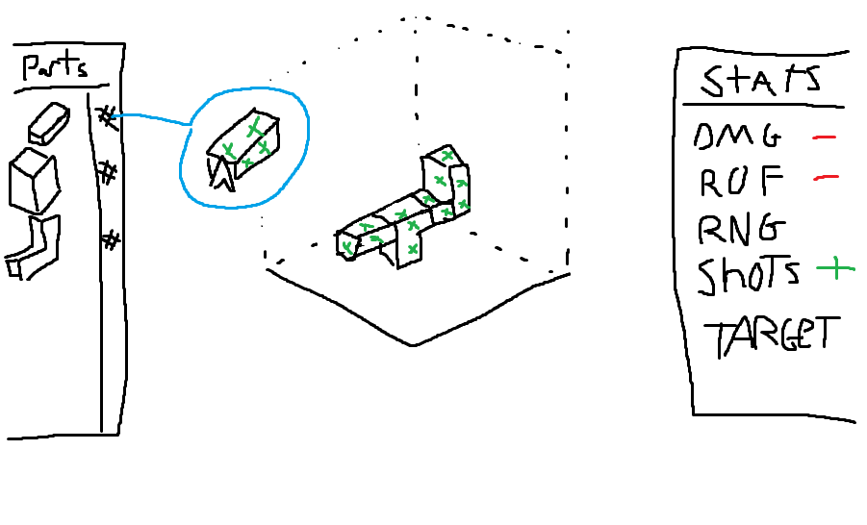

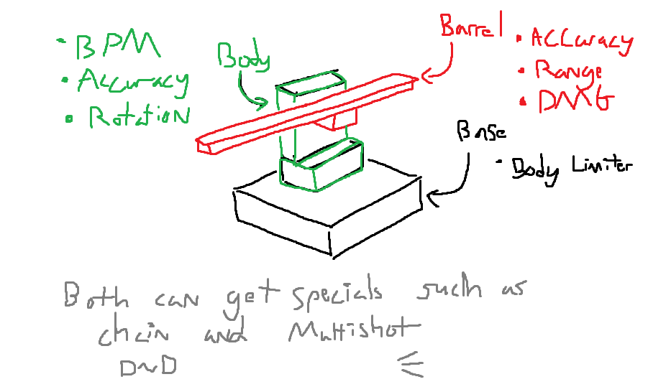

#### 

#### Turret Types

Details -

Turrets need to fire different projectiles (IE, arc, beam, normal, homing, split)

Different blocks provide different options randomly

Common blocks have prefixes that only work when on the barrel

Mortar, Shotgun, Minigun, Sniper, etc

Rare blocks have prefix modifiers

Chain, Area, Slow, Lightning, Fire, etc

Legendary has special affixes (not always good, but interesting)

Black hole, Teleport, Shrink, etc

All blocks have stats to provide to the turret with different stats in different locations (see image above)

Barrel focuses on actual damage, range and accuracy (firing stats)

Body focuses on speed, tracking and fire rate (aiming and BPM)

Base does nothing, but determines overall size of turret

Both sections can obtain the special effects (Prefixes, Affixes)

Stacking effects increases what they do or just provide a dmg multiplier

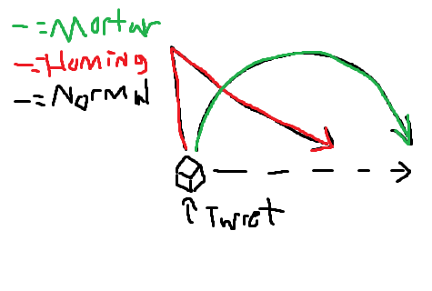

Base is multiple of 5 and takes up multiple tiles

Price of turret has been suggested to either be based on base size or type of projectile

### Level Layout

Use - Each level will be composed of preset parts clicked together

Details -

The level is built out of a grid of square objects

Each object contains sub-objects (3x3) and if it has a path, must have an exit

The path is illuminated by a dotted line or trail, red lines distinguish between patches

The origin point is the escape obj

Requirements -

The visual path that dynamically updates

Enemies that can follow the path

Means of detecting open space size

Detect where blocks connect

This means for saving the layout (for multiple sessions)

Have an ID for all blocks, add ID for new ones, fix conflicts via shuffling)

Extra -

Could be either random or just for ease of making levels

Possibly a level editor

Possibly blocks that only spawn not pass through

Blocks that cannot be placed on

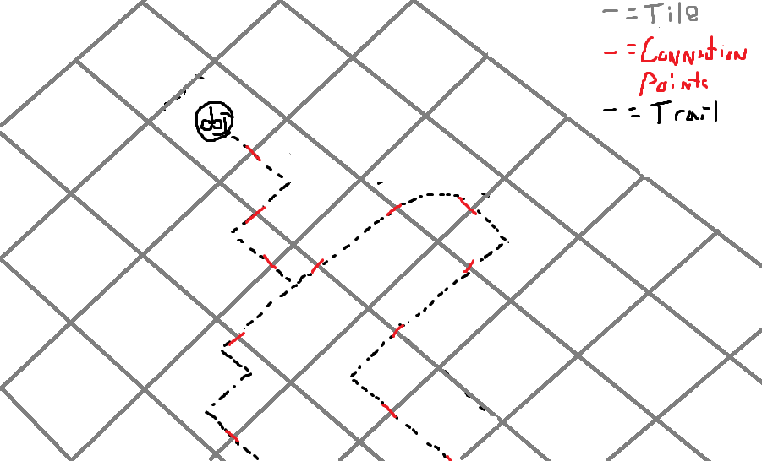

### Menu Order

Use - Navigating throughout the games

Details -

Needs a consistent format and color scheme

Maintain settings between playthroughs

Prevent user from dragging screen size (Presets)

Unlocked Cursor

Requirements -

A title screen

Level Select

Settings (Audio, size of the screen, etc)

Scoreboard

Level Editor

Turret Editor

Extra -

Possibly different menu styles

Dynamic background of gameplay

Random gen turrets on the main menu

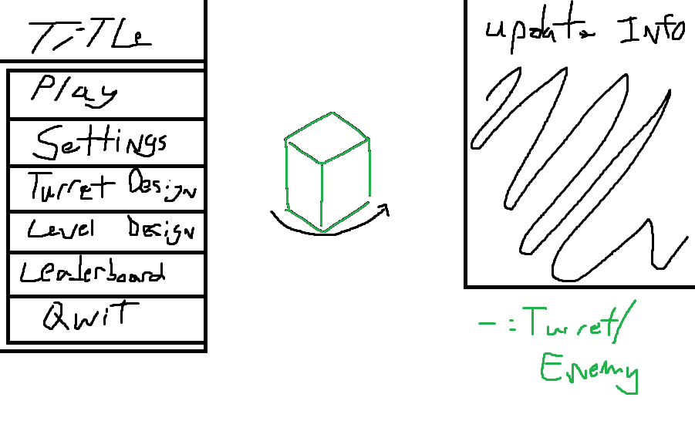

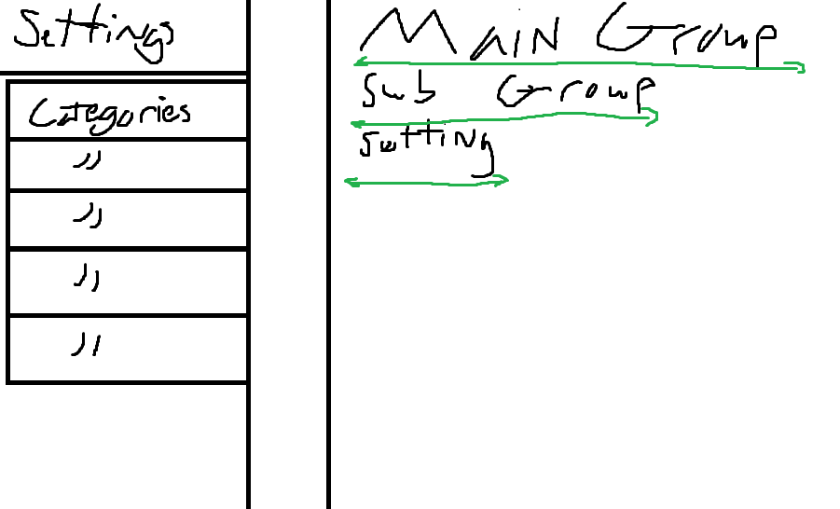

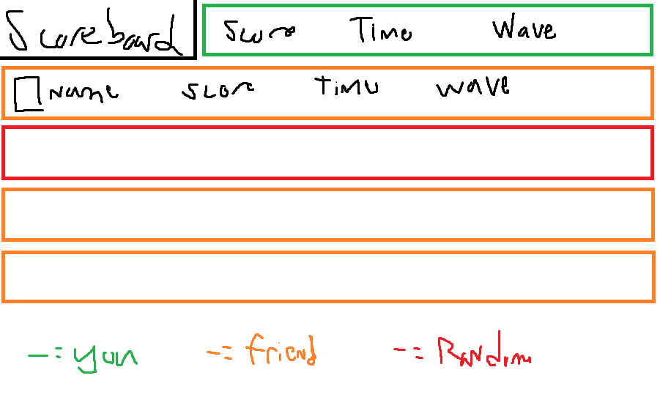

### Enemy Types

Use - The player requires enemies to fight against and they should probably be scaling difficulty given the infinite length

Details -

Variable types (ie shield, armor, health, speed, health, splitting, distraction, healing)

Boss waves of some sort

Turrets should specialize against some types either by damage types or direct enemy bonuses

Spawn amounts fixed in premade levels  
 Probably rounded compared to the rigid turrets

Requirements -

Spawning table

Scaling stat calculation that is not overkill

Table of different enemy types

Distinct models (mine will be bad, might want to acquire models unless I want to learn animation)

Extra -

Possibly ones that change the terrain or attack your turrets

Random gen them like turrets or levels?

Custom models

### Save System

Use - For users to save information between sessions (turrets, maps, progress)

Details -

Might be able to use Steamworks once its actually done

Should be simple and organized

Requirements -

Will develop these as I determine more about how the turrets, levels, and enemies are created

Will most likely use either XML or JSON and save it to a player folder

DO NOT USE UNITY PLAYER STATS (causes bloat)

Extra -

Allow user to choose save location

